**Bash scripting -2**

1) Create a bash script to **check if a directory is available or not**

* Create a bash file with extension bash/.sh
* Enter the bash script as the given syntax

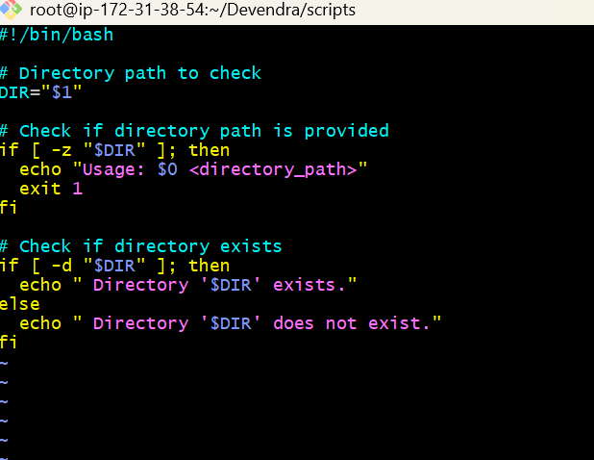

* Change the permissions to 755 to the file

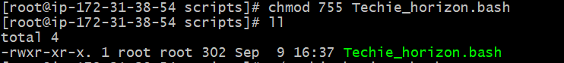

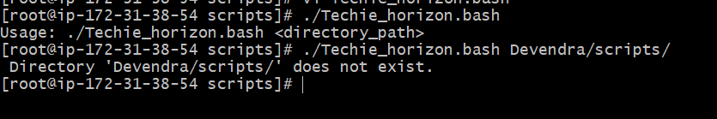

2) Create a bash script to **create multiple files**

* Create a file with extension of bash.sh
* Enter bash script as below

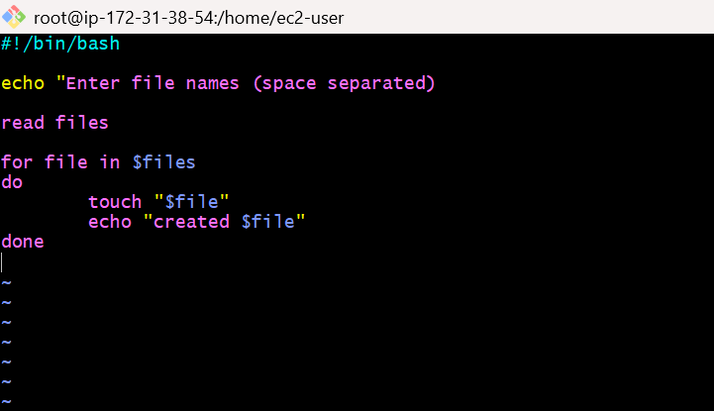

* Give permissions by using **Chmod 755 multiple_files.bash**

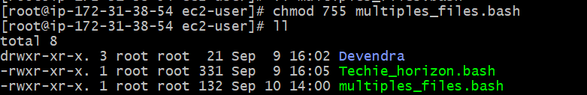

* ./multiple_files.bash - Execute the script

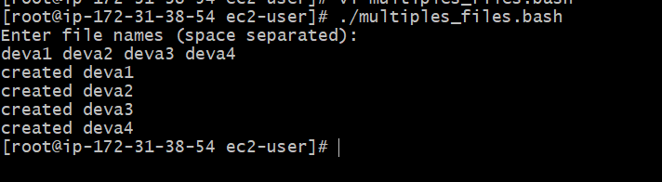

3) Create a bash script to **take a backup of a directory**

* Create a file with the extension of sh
* Enter the bash script as below

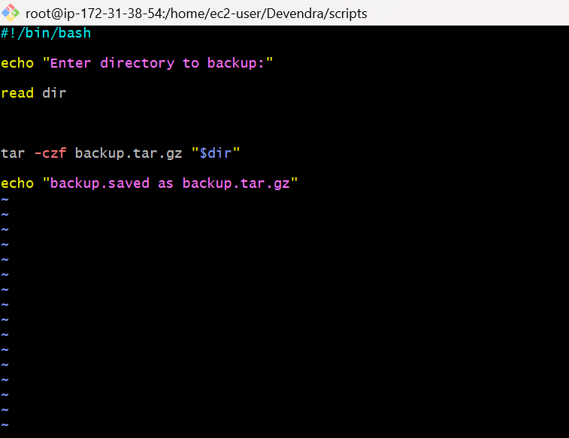

* Give permissions by using **chmod 755 backup.bash**

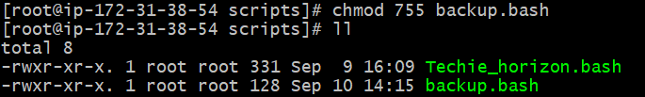

* Execute the script by using **./backup.bash**

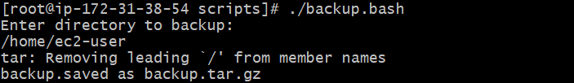

4) Create a bash script to **install Nginx on an EC2 server**

* Sudo yum install nginx –y
* Sudo systemctl start nginx
* Sudo systemctl enable started

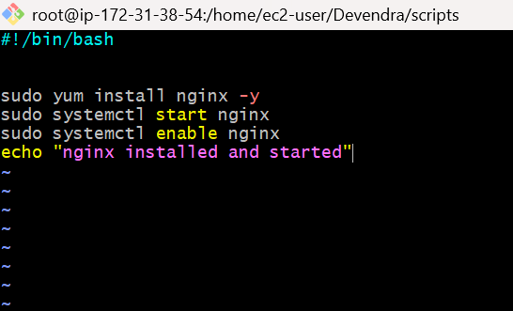

* Give permissions by using - **chmod 755 nginx.bash**

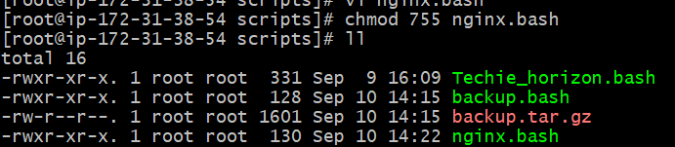

* Execute the script by using - **./nginx.bash**

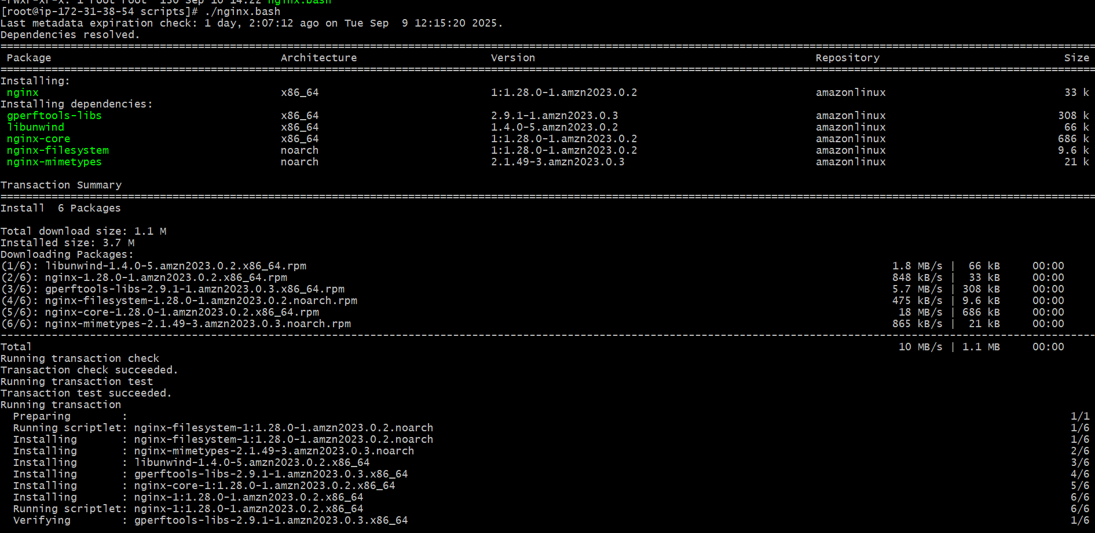

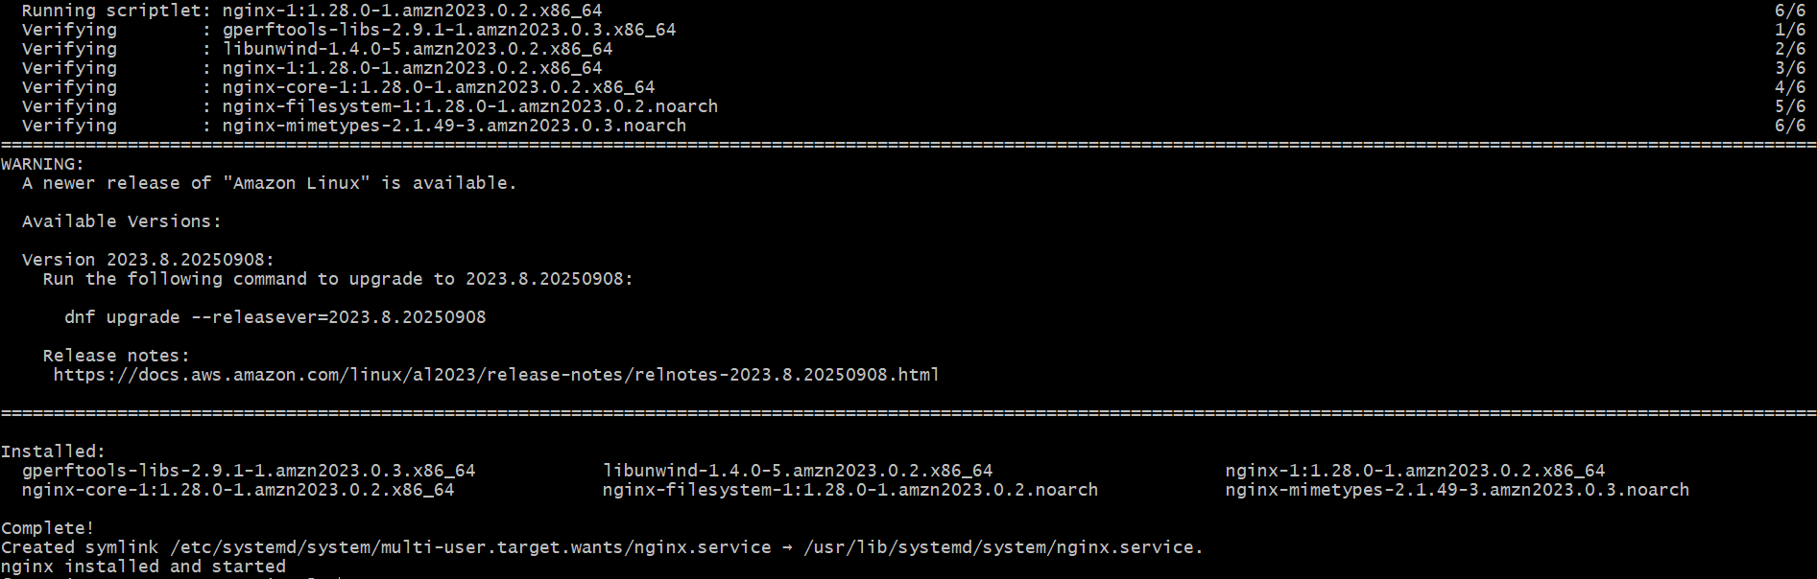

5) Create a bash script to **install Apache Tomcat on an EC2 server**

* Sudo yum update
* Sudo yum install tomcat10
* Sudo yum start tomcat10
* Sudo yum enable tomcat10

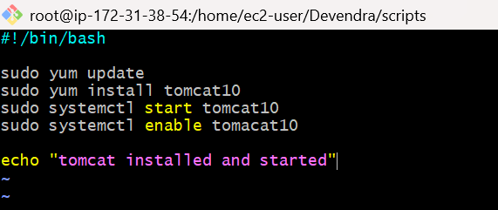

* Give permissions by using **chmod 755 tomcat.bash**

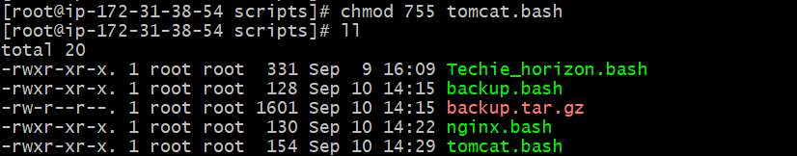

* Execute the script by using **./tomcat.bash**

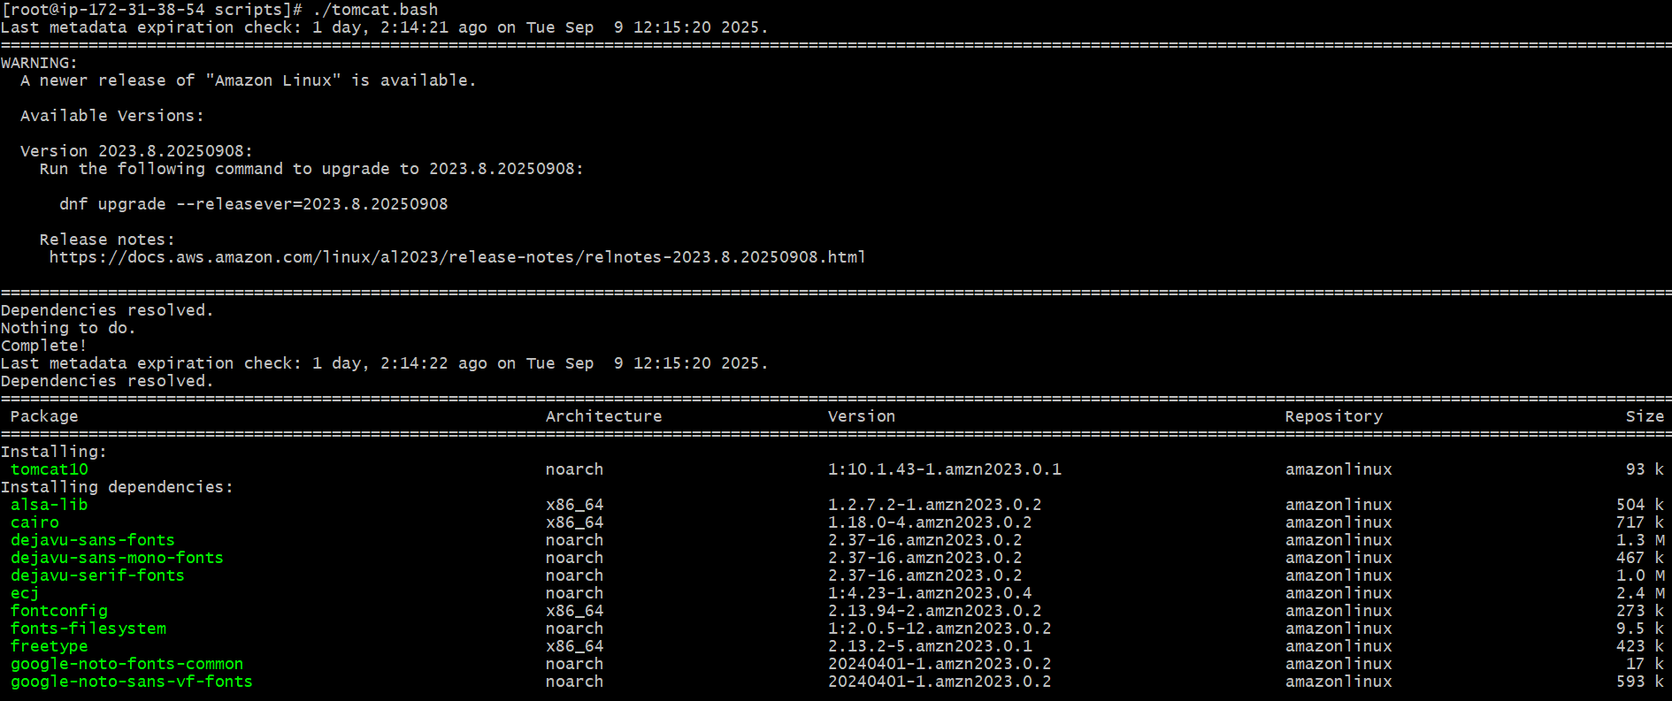

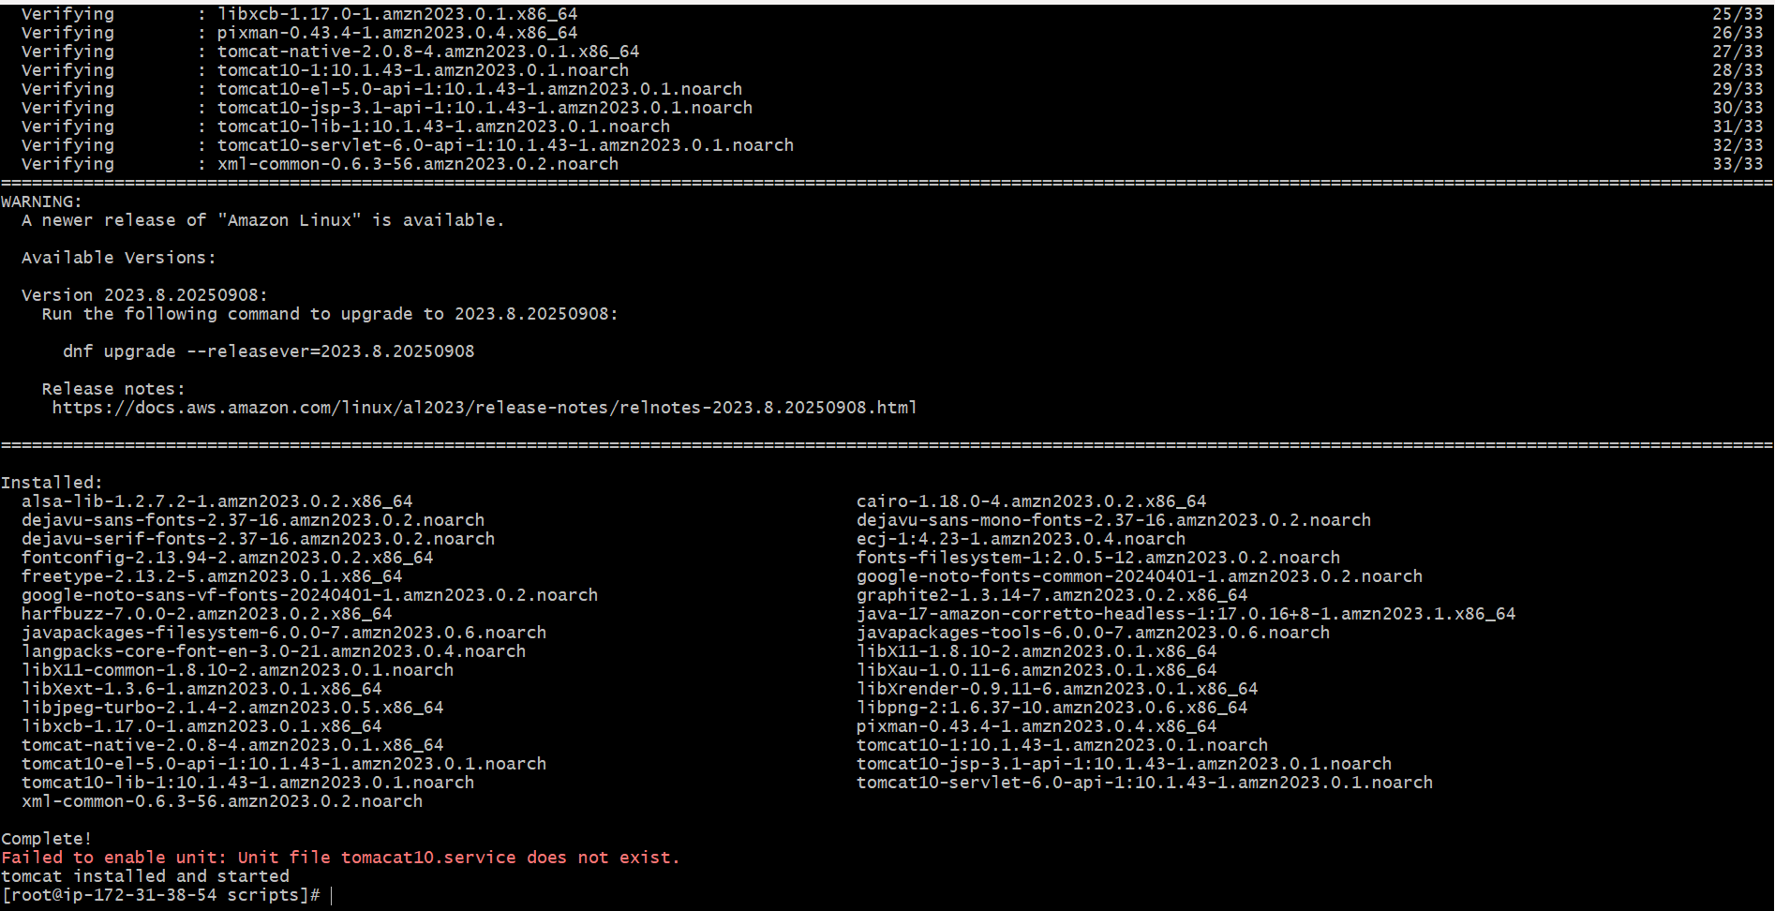

6) Create a bash script to **check if the Nginx service is running**, if not running then script

should start the service.

* Create a file with the extension of sh

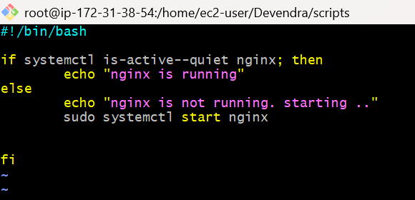

* Giving permissions by using **chmod 755 status.bash**

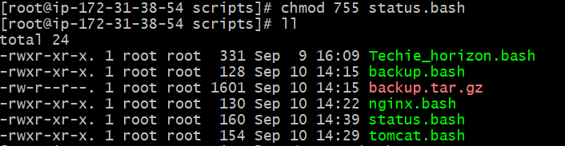

* Execute the script by using **./status.bash**

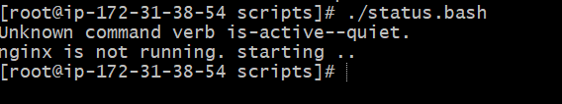

7) Create a bash script for a **calculator**

* Create a file with the extension of sh

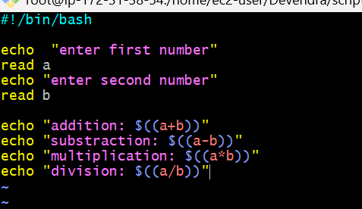

* Giving the permissions by using **chmod 755 calculator.bash**

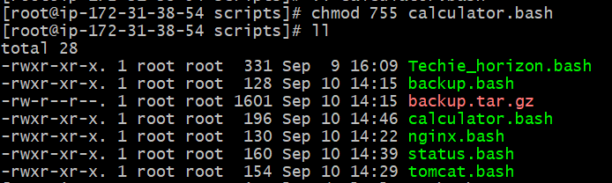

* Execute the file by using **./calculator.bash**

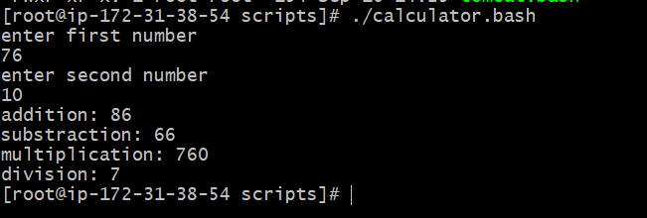

8) Create a bash script to **check if a directory exists**, if not then create a directory

* Create a file with extension of sh

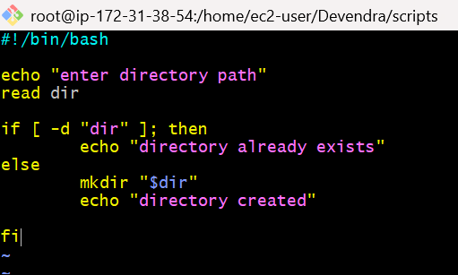

* Giving the permission by using **chmod 755 directory.bash**

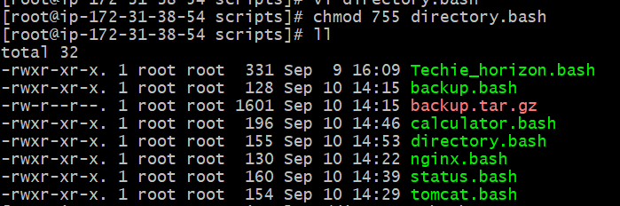

* Execute the script by using **./directory.bash**

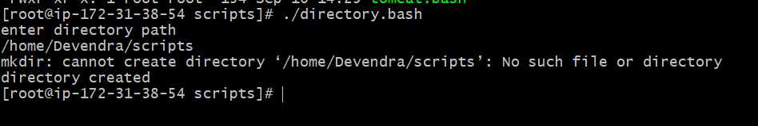

9) Create a bash script to **delete the last 3 lines of a file**

* Create a file with the extension of sh

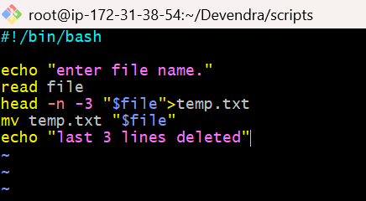

* Giving the permissions by using **chmod 755 delete.bash**

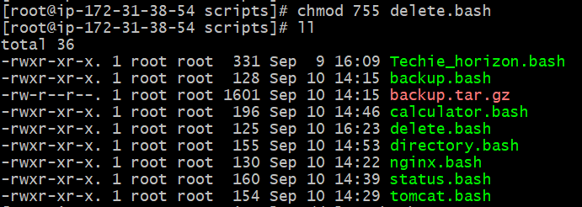

* Execute the file by using **./delete.bash**

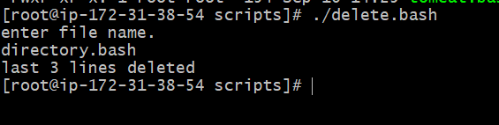

10) Bash script to monitor cpu and if it is more than 80% then send email notification

* Create a file with the extension of sh

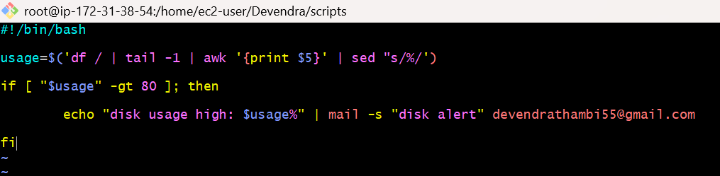

* Giving permissions by using **chmod 755 cpu.bash**

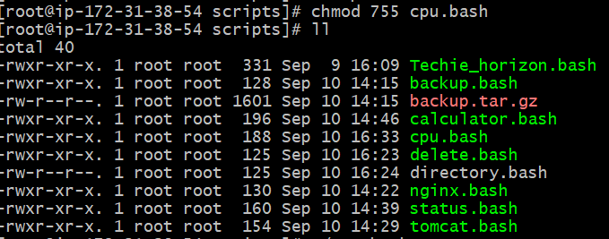

* Execute the file by using **./cpu.bash**

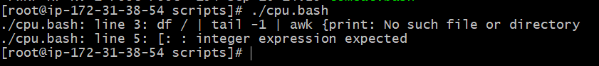

11) Bash script to monitor disk space and if it is more than 80% then send email notification

* Create a file with the extension of sh

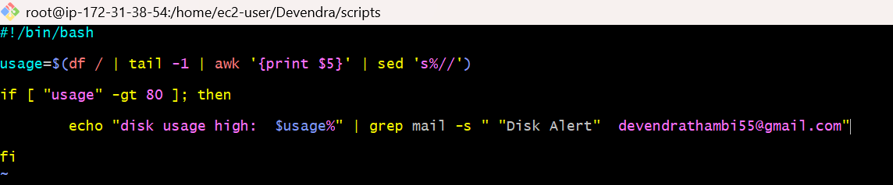

* Giving the permissions by using chmod 755 disk-space.bash

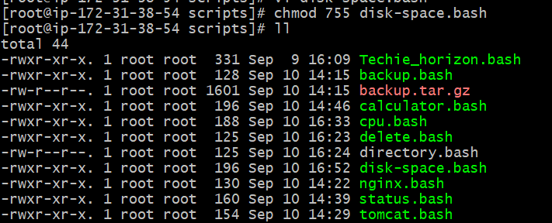

* Execute the file by using ./disk-space.bash

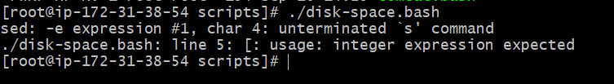

12) Bash script to monitor memory and if it is more than 80% then send email notification

* Create a file with the extension of sh

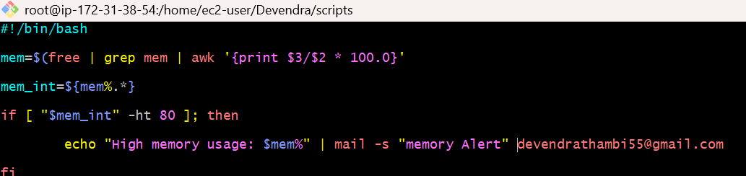

* Giving the permissions by using chmod 755 disk-space.bash

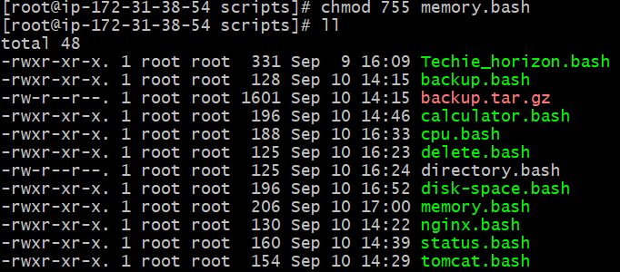

* Execute the file by using ./disk-space.bash

